Pitching - Bunt Defense
Purpose:
Give pitchers practice at fielding bunts and making plays both at 3rd and 1st.
Equipment:
Baseballs
Setup:
You can run this drill with 1 or 2 pitchers at a time. If using 2 pitchers have a pitcher stand on each side of the mound and have 2 catchers on each side of home plate.
Execution:
Each pitcher will go through the pitching motion and throw a pitch to the catcher. The coach will roll out a ball down the third base or first base line. If down the third base line the pitcher will field it and make the pivot and throw to third. If down the first base line the pitcher will make the throw to first.
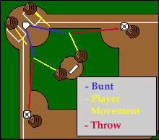
Have one pitcher throw and then the other to keep the drill running continously.
You can also roll some just in front of the plate to have the catchers work on the same drill.

